Good morning!
Please complete the following readings and questions or activity associated with each. Should you not be able to complete this in class, this will be your homework for the weekend. Nonetheless, this will be due on Monday!

Pope Urban II: Speech at Council of Clermont, 1095, according to Fulcher of Chartres

In 1094 or 1095, Alexius I Comnenus, the Byzantine emperor, sent to the pope, Urban II, and asked for aid from the west against the Turks, who had taken nearly all of Asia Minor from him.

"Although, O sons of God, you have promised more firmly than ever to keep the peace among yourselves and to preserve the rights of the church, there remains still an important work for you to do. Freshly quickened by the divine correction, you must apply the strength of your righteousness to another matter which concerns you as well as God. For your brethren who live in the east are in urgent need of your help, and you must hasten to give them the aid which has often been promised them. For, as the most of you have heard, the Turks and Arabs have attacked them and have conquered the territory of Romania [the Greek empire] as far west as the shore of the Mediterranean and the Hellespont, which is called the Arm of St. George. They have occupied more and more of the lands of those Christians, and have overcome them in seven battles. They have killed and captured many, and have destroyed the churches and devastated the empire. If you permit them to continue thus for awhile with impurity, the faithful of God will be much more widely attacked by them. On this account I, or rather the Lord, beseech you as Christ's heralds to publish this everywhere and to persuade all people of whatever rank, foot-soldiers and knights, poor and rich, to carry aid promptly to those Christians and to destroy that vile race from the lands of our friends. I say this to those who are present, it meant also for those who are absent. Moreover, Christ commands it.
"All who die by the way, whether by land or by sea, or in battle against the pagans, shall have immediate remission of sins. This I grant them through the power of God with which I am invested. O what a disgrace if such a despised and base race, which worships demons, should conquer a people which has the faith of omnipotent God and is made glorious with the name of Christ! With what reproaches will the Lord overwhelm us if you do not aid those who, with us, profess the Christian religion! Let those who have been accustomed unjustly to wage private warfare against the faithful now go against the infidels and end with victory this war which should have been begun long ago. Let those who for a long time, have been robbers, now become knights. Let those who have been fighting against their brothers and relatives now fight in a proper way against the barbarians. Let those who have been serving as mercenaries for small pay now obtain the eternal reward. Let those who have been wearing themselves out in both body and soul now work for a double honor. Behold! on this side will be the sorrowful and poor, on that, the rich; on this side, the enemies of the Lord, on that, his friends. Let those who go not put off the journey, but rent their lands and collect money for their expenses; and as soon as winter is over and spring comes, let hem eagerly set out on the way with God as their guide."

Medieval Sourcebook Online: http://www.fordham.edu/halsall/source/urban2-fulcher.html

Part I: The First Crusade

Read the excerpt from the speech given at the Council of Clermont, France, by Pope Urban II, challenging Christians to take up the call of a Crusade to recover the Holy Land. Then, complete the questions and activity.

1. How do the traditions of “peace and truce of God” tie in with the call for a Crusade?

2. Who was the person responsible for the call of a Crusade? Why?

3. What was promised to the Crusaders in return for their service? (Give the specific quote from the text). Why was this an effective incentive?

4. Create a slogan to convince people to join the Crusades. Think about the following:
- If the peasant was to die fighting in the Crusades, his soul was automatically saved.
- The peasants could be free of bonds to their feudal lords while on Crusade.
- The Crusade offered peasants an adventure.

Read the following excerpt. Then, create a timeline that shows what happened during the Third Crusade.

In 1187, the Holy City of Jerusalem fell to Muslim forces under Saladin. Three important rulers agreed to lead a Third Crusade. Emperor Frederick Barbarossa of Germany (Holy Roman Empire), Richard I (The Lionheart) of England, and Phillip II Augustus, King of France. When members of the Third Crusade arrived in the East in 1189, they encountered problems. Frederick drowned in a local river. The English and French arrived by sea and captured the coastal cities with the aid of their fleets, but were unable to move inland against the Muslim forces. After Phillip went home, Richard was kidnapped and had to negotiate a settlement with Saladin that permitted Christian pilgrims free access to Jerusalem.

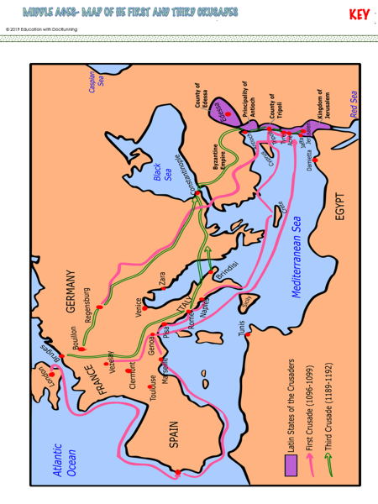

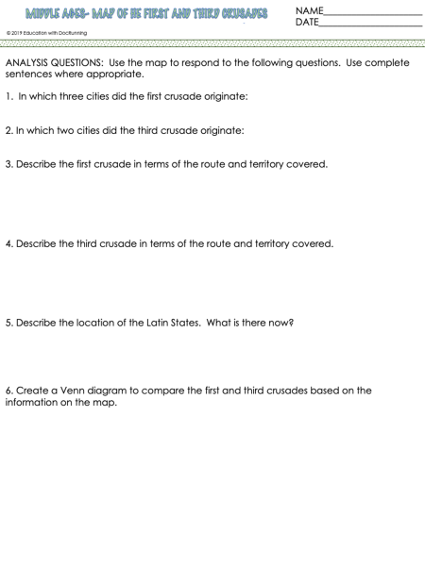
The Children’s Crusade
The Children's Crusade is one of the more unusual events, and took place after the Fourth Crusade (1202 to 1204). The Fourth Crusade had been a disaster for the Christians as many crusaders had not even got to the Holy Land, let alone fight for Jerusalem. Many Christians had used the crusade as a means to plunder valuable goods from abroad; however, the Children's Crusade seemed to put some Christian belief back into crusading.
In 1212, two groups - one from France, the other from Germany - set off on a crusade to the Holy Land. There was nothing unusual about this as many 'armies' had gathered before to fight the Muslims. The major difference about these two groups was that they were composed entirely of young children. These children became convinced that they would be protected by God and that because of this protection they would get to the Holy Land and take Jerusalem for the Christians.
The person who seemed to be in charge was a boy called Stephen of Cloyes. We know very little about him. We know that he was a shepherd and that in 1212 he was 12 years of age. With a peasant's background, he would not have been able to read or write and at his age he would have done very basic work around a farm. In May 1212, it is said that he turned up at the court of King Philip of France and told him that he had a letter from Christ ordering him to organize a crusade. Not surprisingly, King Philip was not impressed and told him to go away and come back when he was older! Regardless of this rejection, Stephen went around preaching to children about his letter from Jesus and his desire to capture Jerusalem. He told his followers that crossing the Mediterranean or any other waterways was easy as the waters would part and they would walk across as they were protected by God. By June 1212, Stephen is said to have gathered 30,000 followers around him, all children.
The Children's Crusade was doomed to failure. Many of the children had never walked such distances before and for many the effort proved too much. The journey from Vendome to Marseilles in France caused many children to drop out. Some even died of exhaustion. The sea did not part as Stephen had said and they had to cross the Mediterranean Sea by boat. The children boarded seven boats in Marseilles and that was the last anything was heard of them.
However, many years later, a priest returned from traveling around northern Africa and he claimed to have met some of the surviving children (now adults). He claimed that two of the seven ships had sunk, killing all on board, and that pirates had captured the other five ships and the children were sold into slavery. White skinned children were considered to be a valuable prize in Algerian and Egyptian slave markets.
A German Children's Crusade also took place in 1212. This was lead by a boy called Nicholas and he had 20,000 followers. His dream was exactly the same as Stephen's; to take Jerusalem for Christianity. This crusade also included religious men and unmarried women so it was not fully a Children's Crusade. Their journey south from Germany to Italy included a very dangerous crossing of the Alps and many died of the cold here. Those that survived pushed onto to Rome in Italy. Here, they met the pope. He praised their bravery but told them that they were too young to take on such a venture. With this, they returned to Germany but a great many of them did not survive the journey back. A few stopped off at the Italian port of Pisa and boarded a ship for the Holy Land. No one knows what happened to them.
The Children’s Crusade

Read the description of the Children’s Crusade. Then, create a quick poster to advertise for or against the Children’s Crusade in the space below. Be sure to be persuasive!

The Crusades kept all Europe in a tumult for two centuries, and directly and indirectly cost Christendom several millions of lives (from 2,000,000 to 6,000,000 according to different estimates), besides unknown expenditures in treasure and suffering. Other deaths were due to the disorder, license, and crime with which war is always accompanied. On the other hand, the Holy Wars were productive indirectly of so much and lasting good that they form a most important factor in the history of the progress of civilization.
The Crusades contributed to increase the wealth of the Church and the power of the Papacy. Thus the important part which the Popes took in the Crusades naturally fostered their authority and influence, by placing in their hands, the armies and resources of Christendom, and accustoming the people to look to them as guides and leaders.
As to the wealth of the churches and monasteries, this was increased by the sale to them, often for a mere fraction of their actual value, of the land of those preparing for the expeditions, or by the out and out gift of the lands of such in return for prayers. Thousands of the crusaders, returning broken in spirits and in health, sought an asylum in the churches, and gave the establishments that they entered all of their worldly goods. Besides all this, the stream of the ordinary gifts of piety was swollen by the extraordinary religious enthusiasm of the time.
The influence of the Crusades upon the intellectual development of Europe can hardly be overestimated. Above all, they opened the minds of the crusaders. The East at the time of the Middle Ages surpassed the West in civilization. The crusaders enjoyed the advantages which come from travel in strange lands and among unfamiliar peoples. They went out from their castles or villages to see great cities, marble palaces, superb dresses, and elegant manners; they returned with finer tastes, broader ideas, and wider sympathies. The crusades opened up a new world. Furthermore, the knowledge of the science and learning of the East gained by the crusaders through their expeditions, greatly influenced the Latin intellect, and helped to awaken in Western Europe that mental activity which resulted finally in the great intellectual outburst known as the Revival of Learning during the Renaissance.
http://middle-ages.org.uk/effects-of-crusades.htm

Effects of the Crusades

Using the previous sheet and your background knowledge, answer the following questions in complete sentences.

1. How many people died during the Crusades? Why do you think it’s hard to estimate a range?

2. What effects did the Crusades have on the wealth of the Catholic Church?

3. Do you think feudalism would have continued if the Crusades did not happen? Why or why not?

4. What is one way in which the Crusades strengthened the relationship between Muslims and Christians?

5. What is one way in which the relationship between Muslims and Christians worsened?

Answer the following question with a paragraph of a minimum of 5-6 sentences.
Which Crusade was the most successful? Which was the least successful? Why? Be sure to give specific information in your response!

